**DS nano: Deep Learning**

**Lesson3_Training Neural Networks**

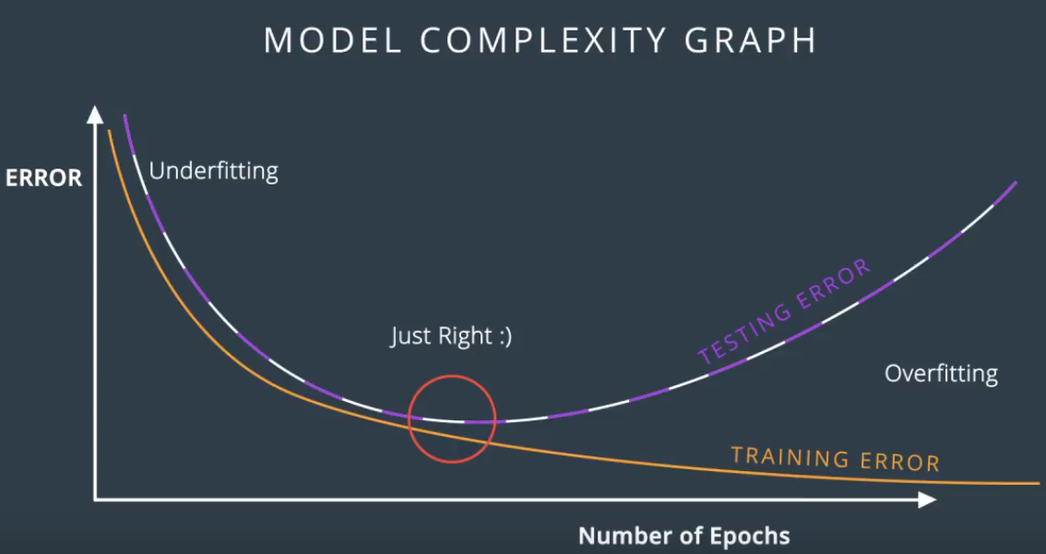

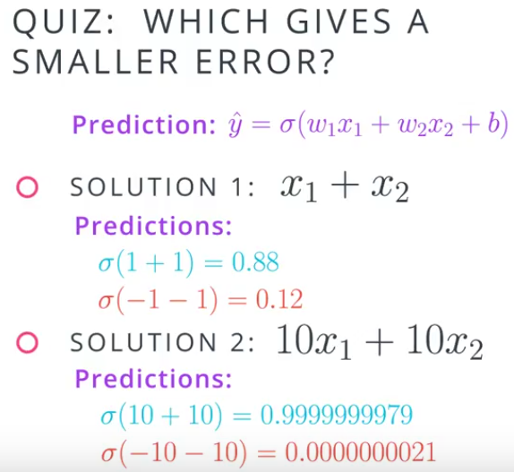

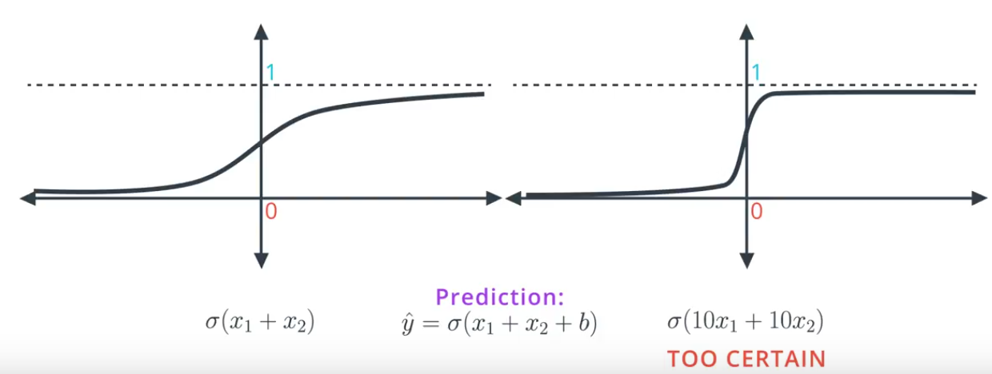  
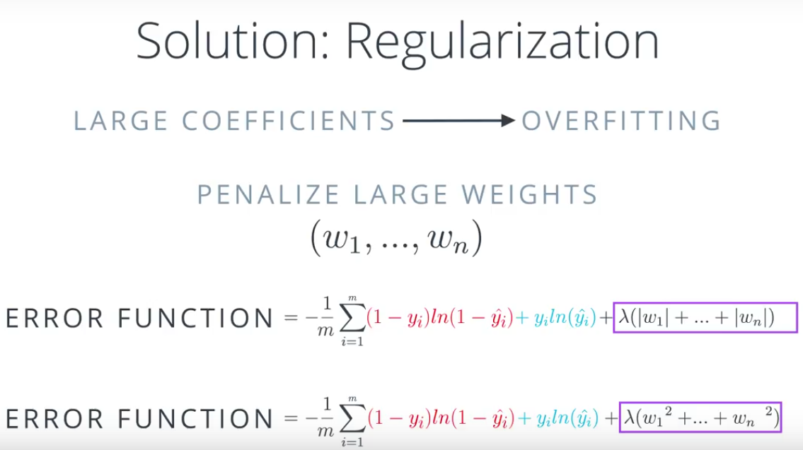

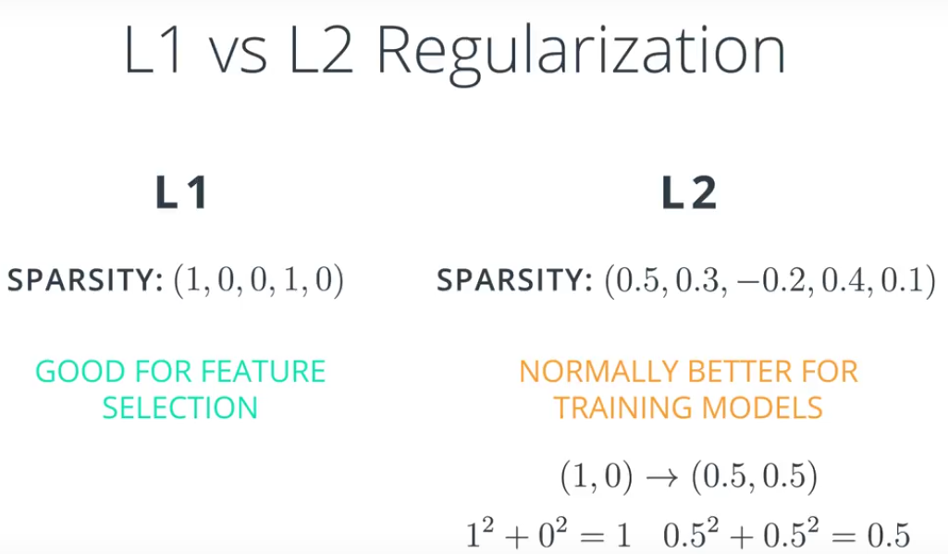

LOCAL MINIA:

* Random start
* Momentum

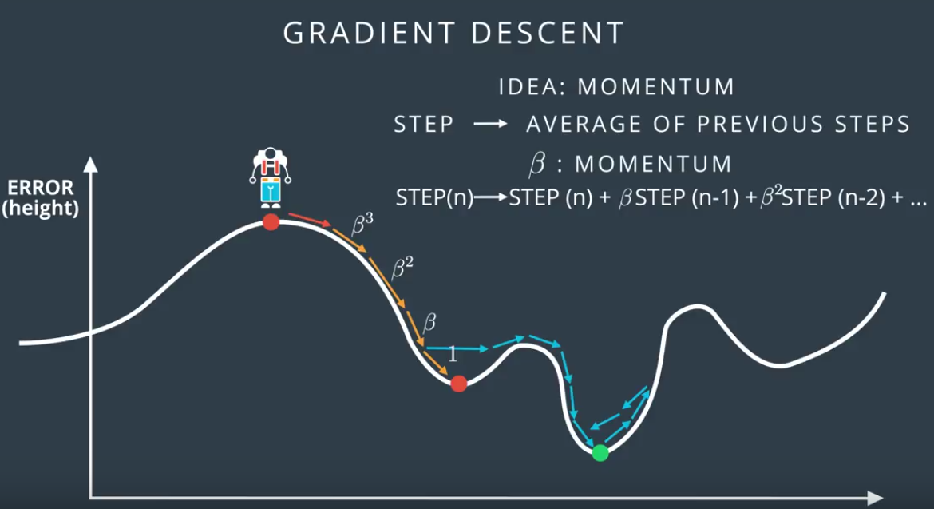

Get larger derivatives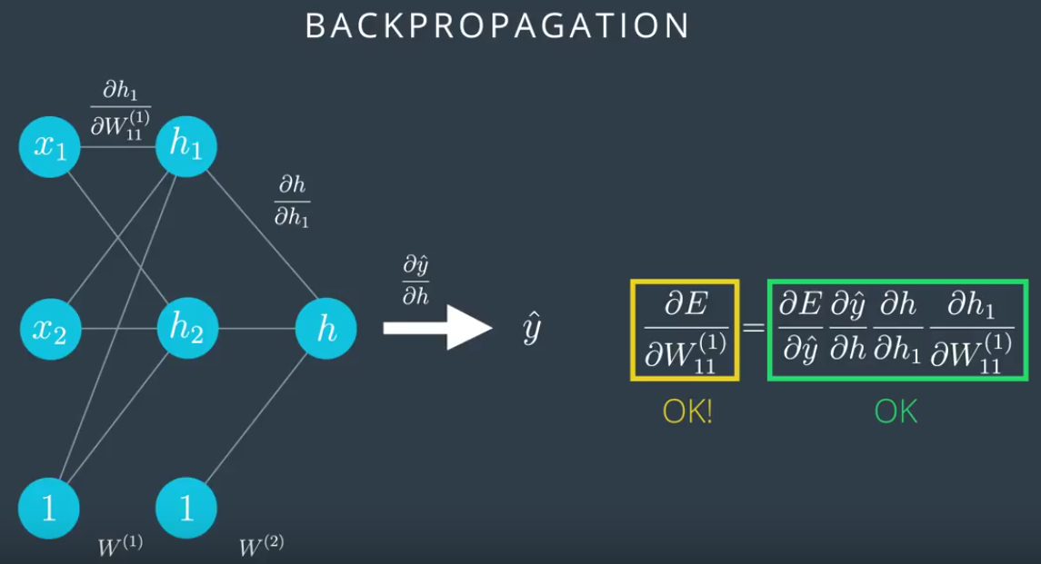

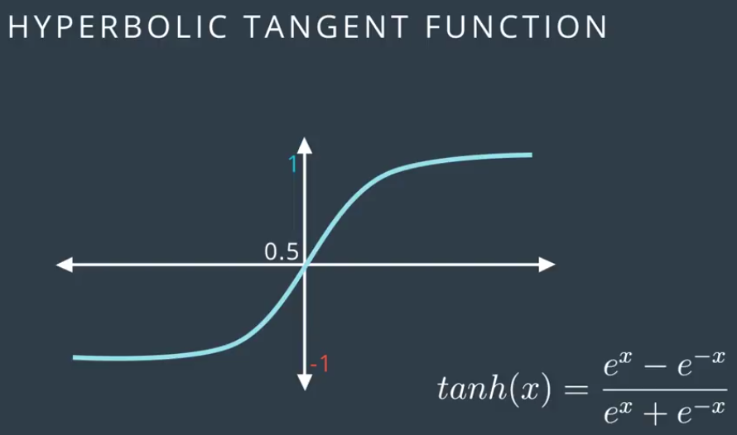

Hyperbolic tangent fxn: derivatives are larger

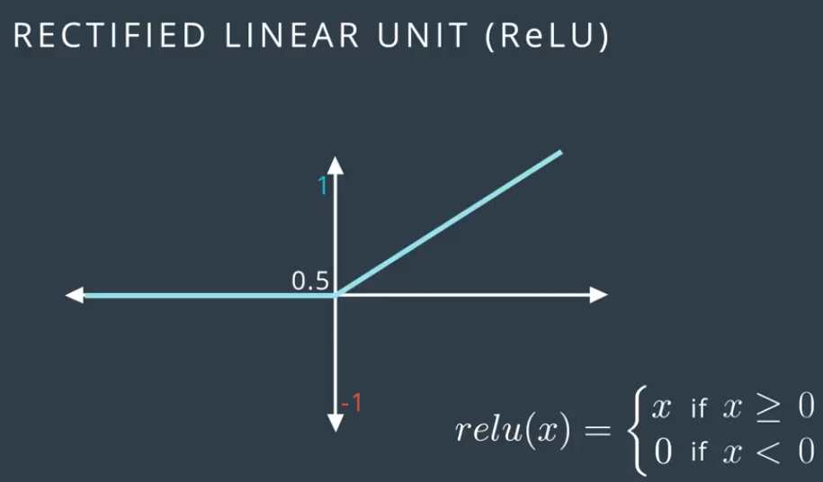

**DS nano: Unsupervised Learning**

**Lesson1_Clustering**

Clustering is one of the most popular unsupervised approaches. In a first look at clustering, you will gain an understanding of what clustering your data means. Then, you will see how the k-means algorithm works. You will put your skills to work to find groupings of similar movies!

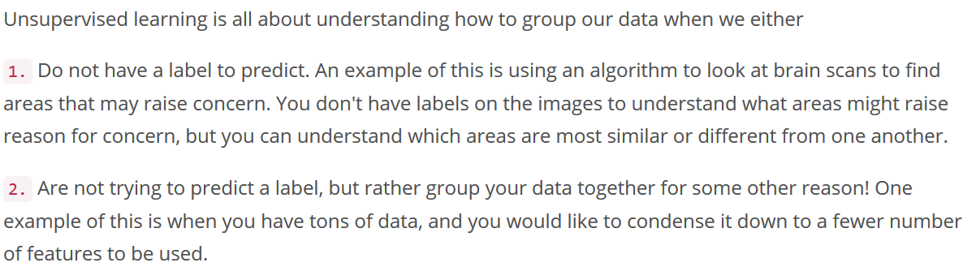

**Clustering** - groups data together based on similarities;

**Dimensionality Reduction** - condenses a large number of features into a (usually much) smaller set of features.

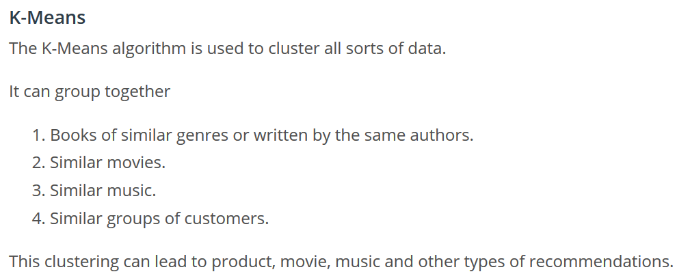

QUIZ 1.6

**Elbow Method for finding K**

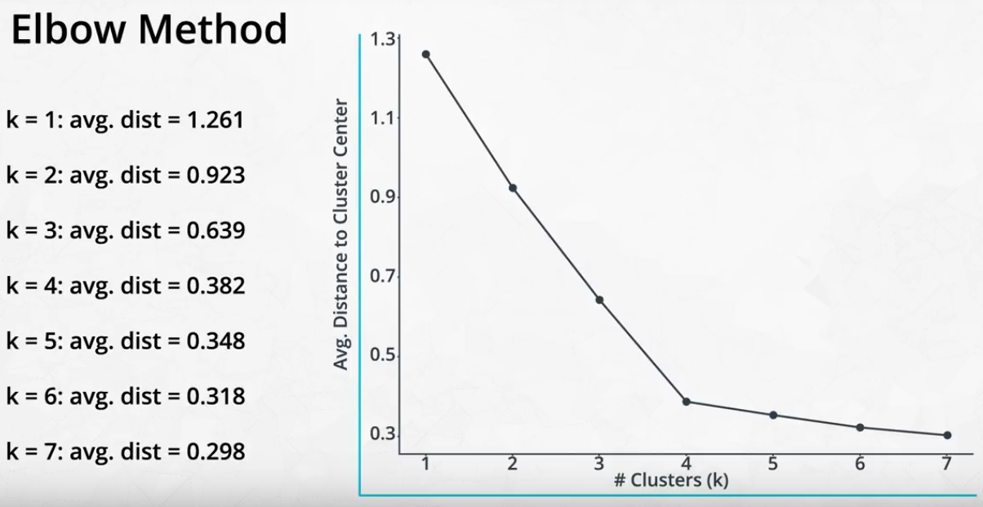

**DS nano: Unsupervised Learning**

**Lesson2_Hierarchical and Density Based Clustering**

Another set of clustering algorithms takes an approach of using density based 'closeness' measures. At the end of the lesson, you will see how this can be used in traffic classification, as well as in anomaly detection (finding points that aren't like others in your dataset).

**DS nano: Unsupervised Learning**

**Lesson3_Gaussian Mixture Models and Cluster Validation**

To extend the density based approaches, you will get some practice with gaussian mixture models. This technique is not far from what you learned in the previous lesson, and it is the last of the clustering algorithms you will learn before moving to matrix decomposition methods.

**DS nano: Unsupervised Learning**

**Lesson4_PCA**

Principal component analysis is one of the most popular decomposition methods available today. In this lesson, you will learn how matrix decomposition methods work conceptually. Then you will apply principal component analysis to hand written digits to reduce the dimensionality of these images.

**DS nano: Unsupervised Learning**

**Lesson5_Random Projection and ICA**

Another way to decompose data is through independent component analysis. In this lesson, you will see how this method can pull apart audio related to a piano, cello, and television that has been overlaid in the same file.

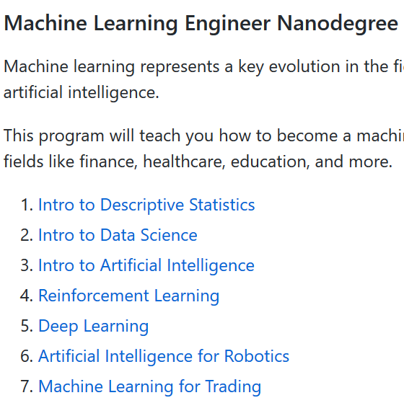

**Deep learning**

Lesson 1 from ML to DL

**Softmax**

